TASK 6:

* Create a Virtual Machine and install Hyper-V role on that VM
* Inside Hyper-V install an windows server.
* Enable internet connectivity on the Hyper-V machine.

Steps to perform above task:

Step 1: Create Virtual Machine by using Azure Virtual Machine service.

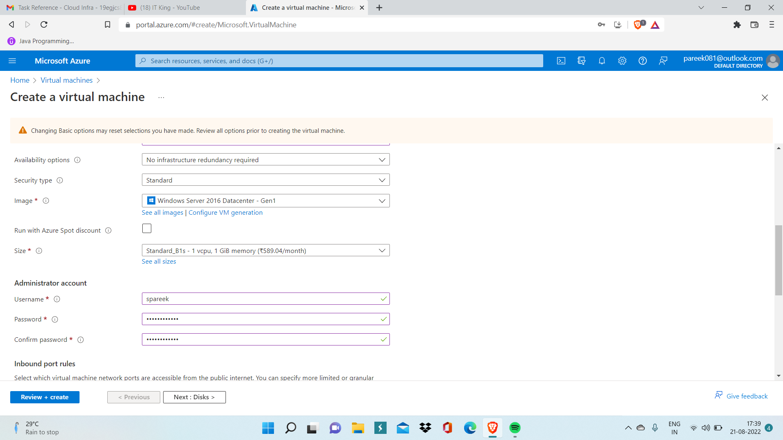

Step 2: Now after Virtual Machine is deployed, Go to Overview Page of your VM.

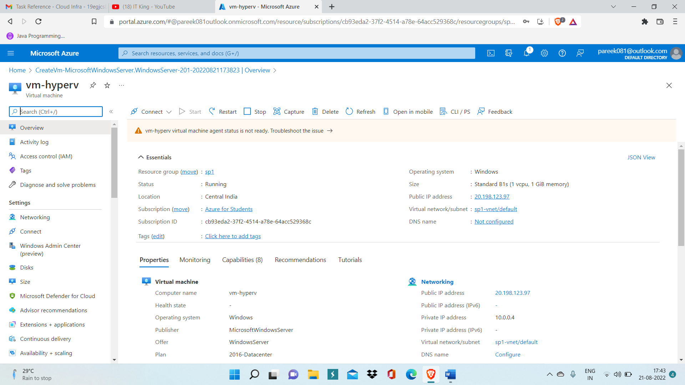

Step 3: Now attach a new disk in this hyperv machine which we will specifically use for hyperv

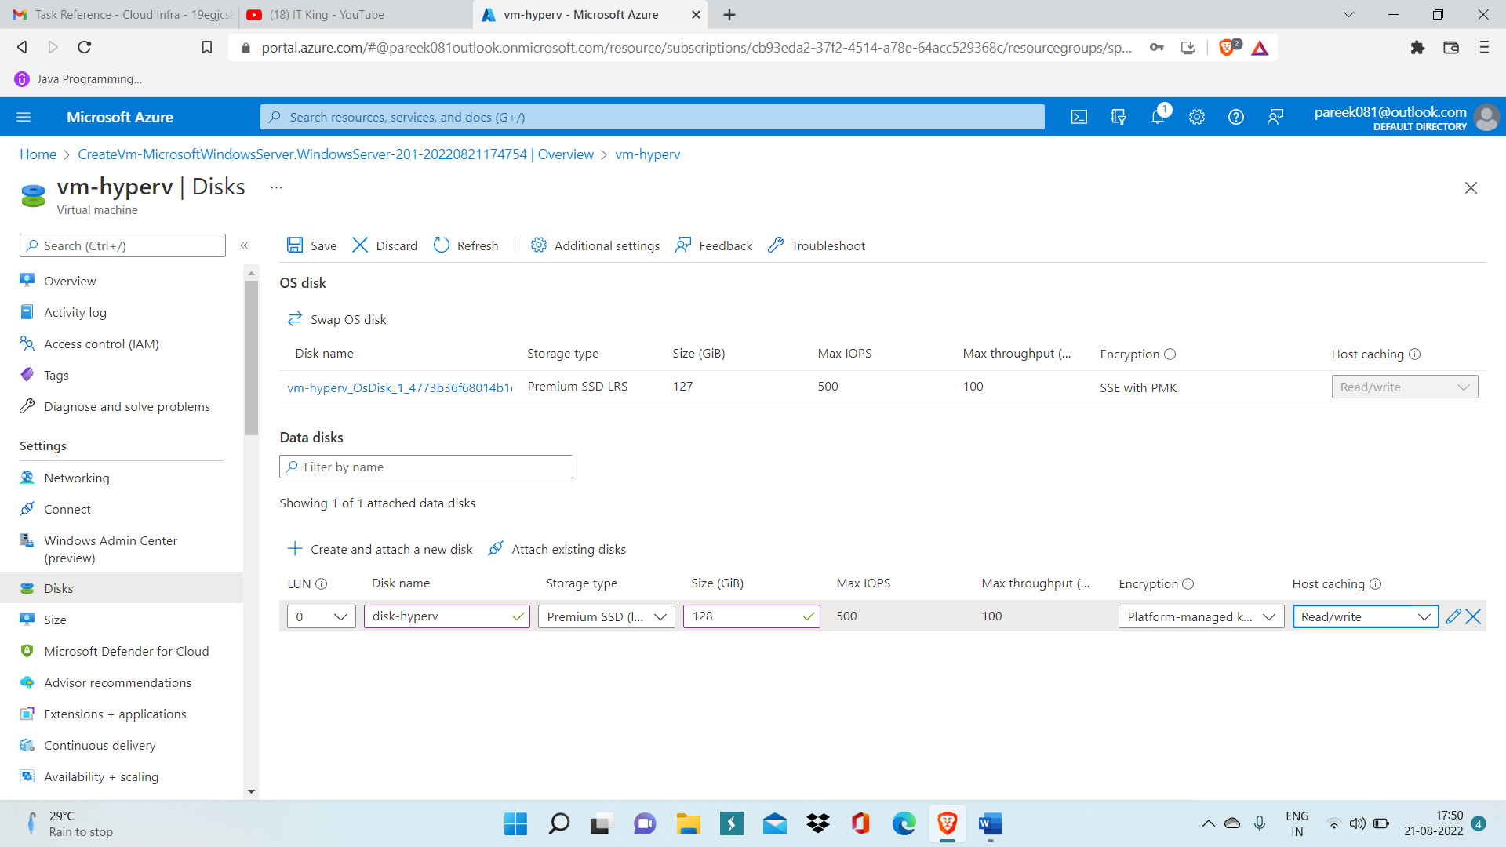

Step 4: Now Connect to VM using RDP and enter authentication details.

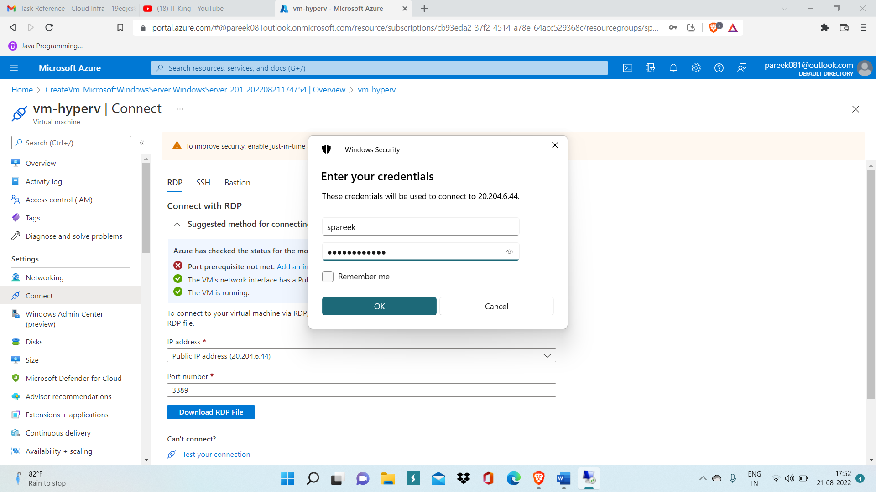

Step 5: Now inside VM, got to Server Manager and then click on Add roles and Features.

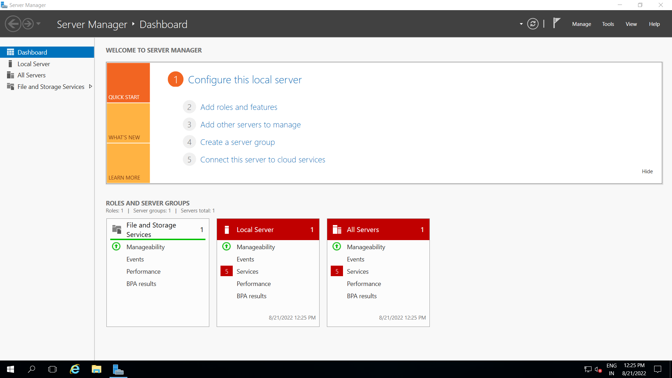

Step 6: Now, add hyperv role inside it and then click on Install to install hyper inside your VM.

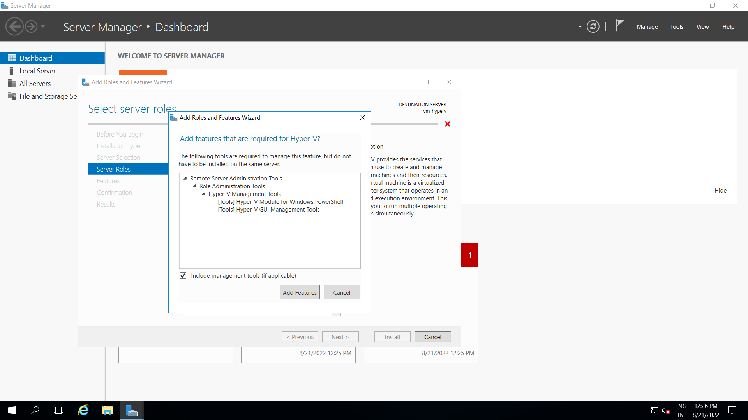

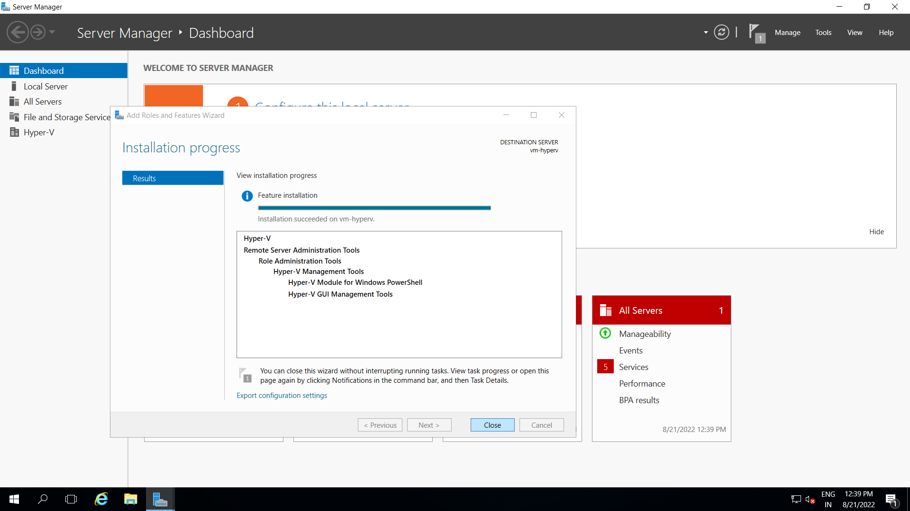

Step 7: Now go inside Hyper v manager, you can easily find it inside Tools menu.

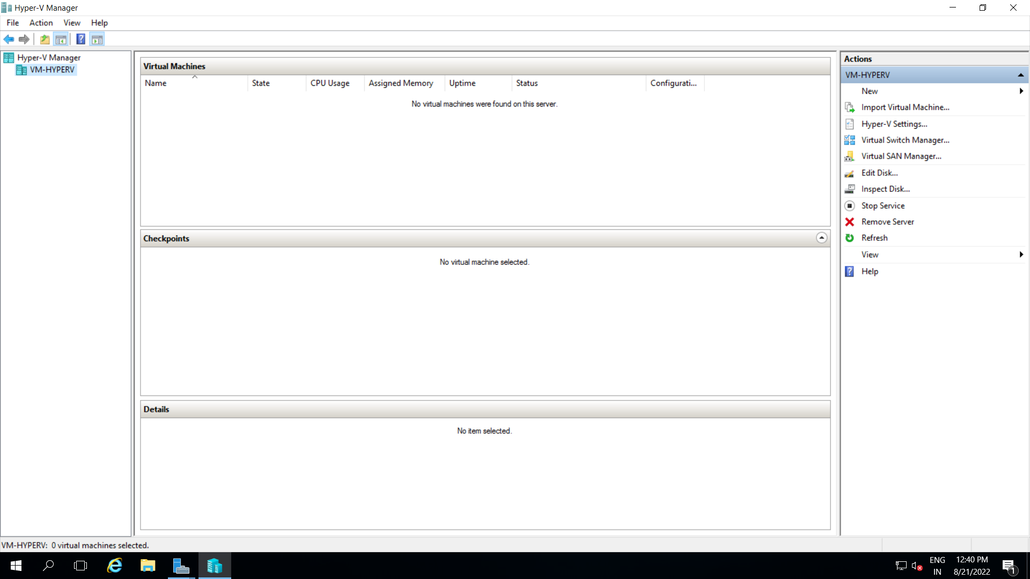

Step 8: Now right click on VM-HYPERV and click on New virtual machine and New Virtual Machine Wizard will get opened.

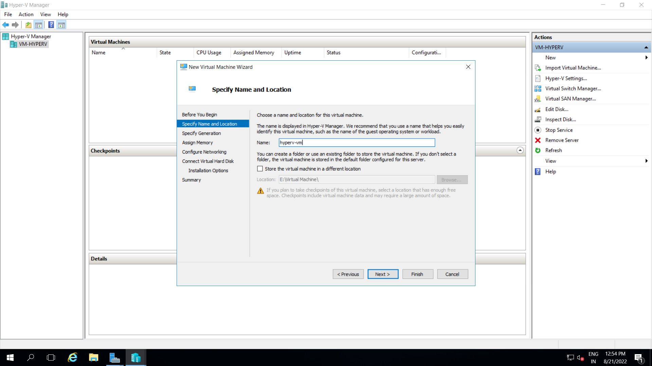

Step 9: Select Configure network and make sure to provide path of your windows iso image and give Hyper V VM name ‘hyper-vm’.

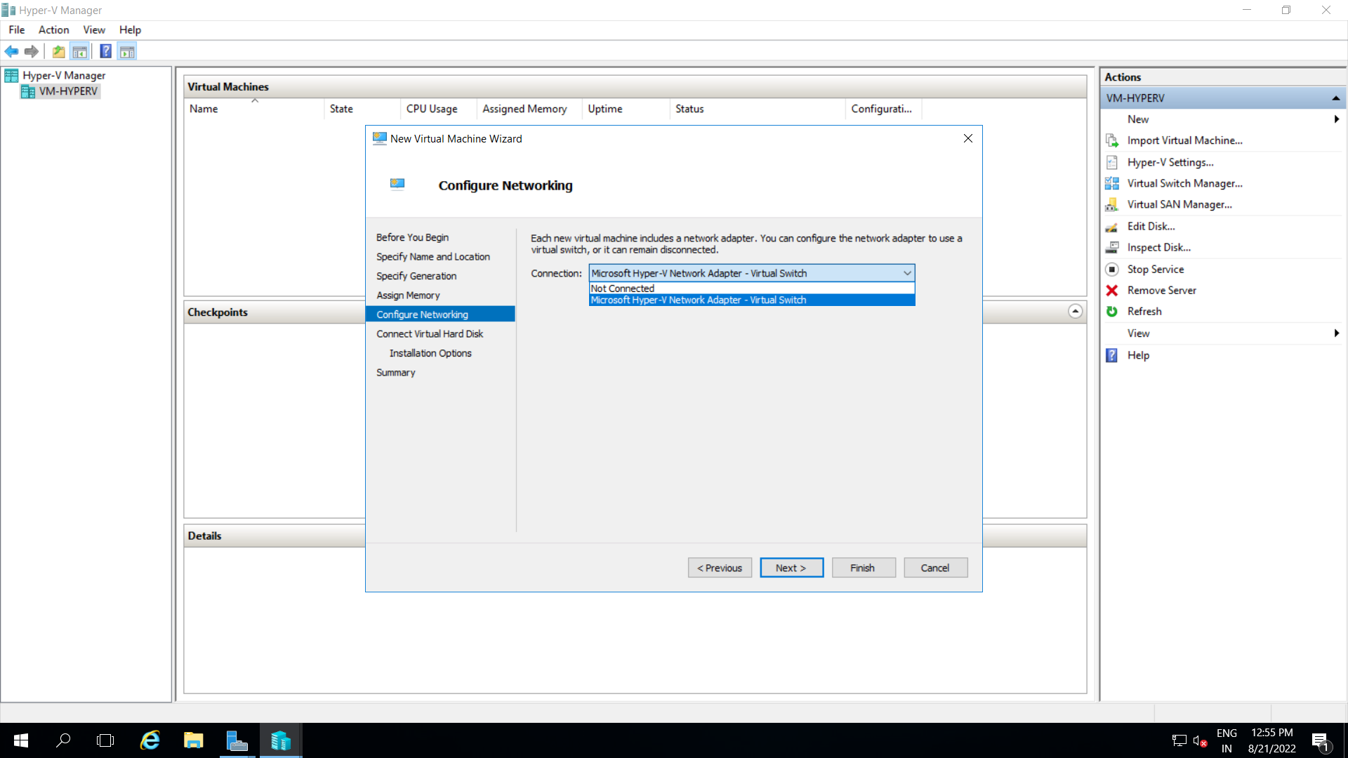

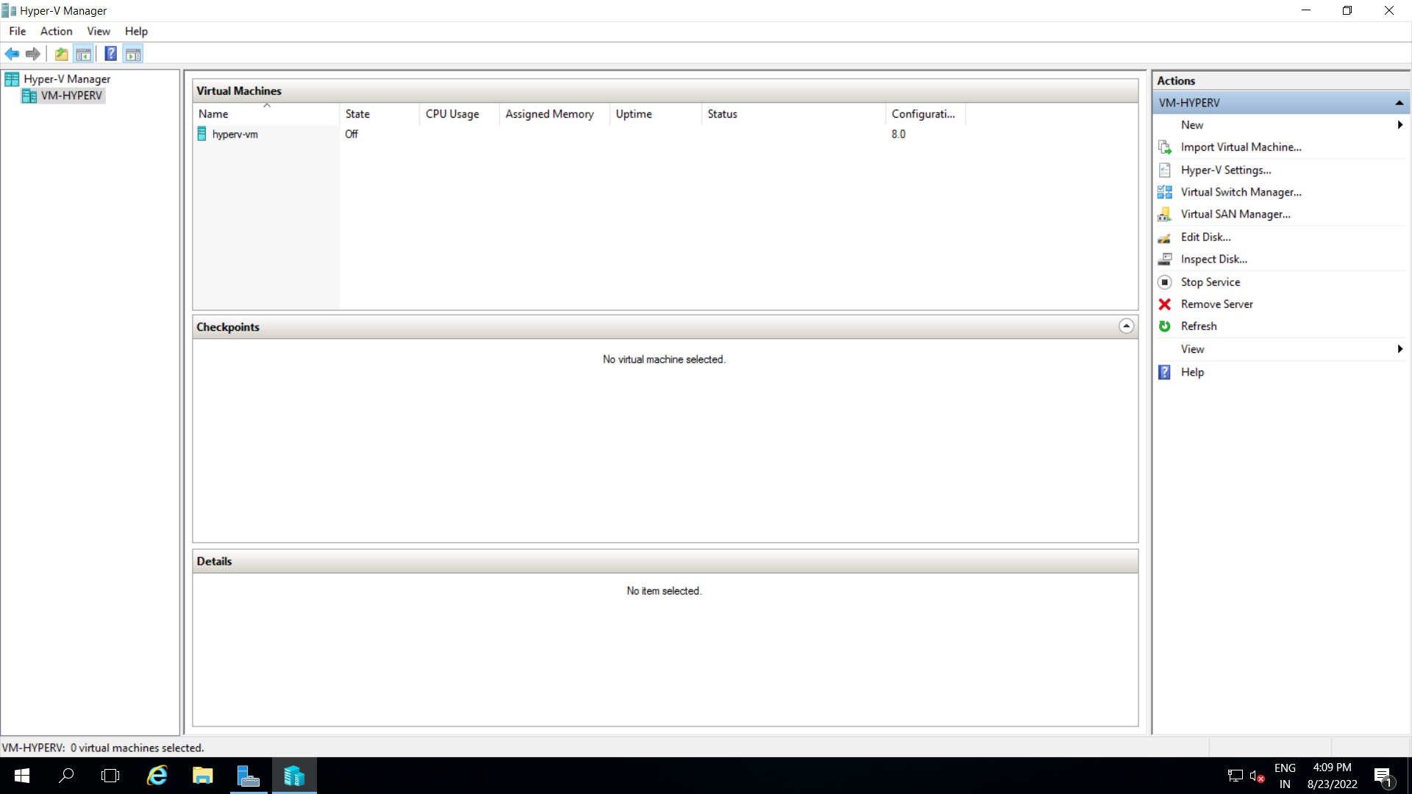

Step 10: Now start hyper-vm virtual machine.

Step 11: Inside Networking sharing centre, configure properties of IPv4.

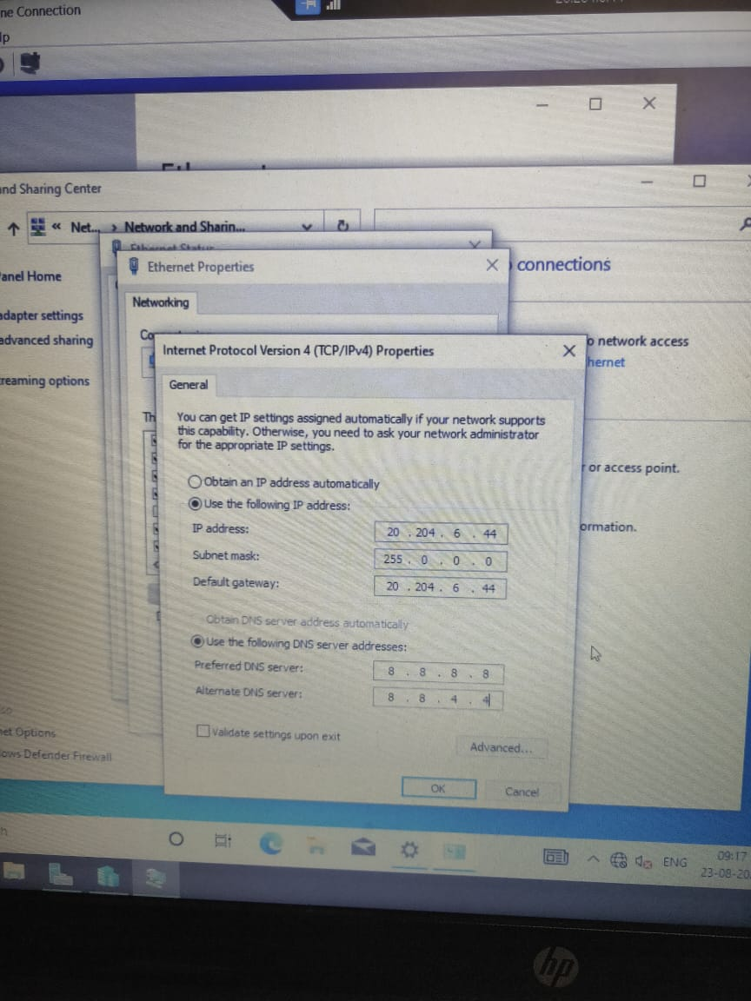

Step 12: Now You can access Internet. Open Microsoft Edge.

